|  |  |
| --- | --- |
| **TEAM ID** | **PNT2022TMID46351** |
| **PROJECT TITLE** | **NUTRITION ASSISTANT APPLICATION** |

**SPRINT-2 _OUTPUTS**

**i) Register**

New user can register them by entering their details like name, email, password.

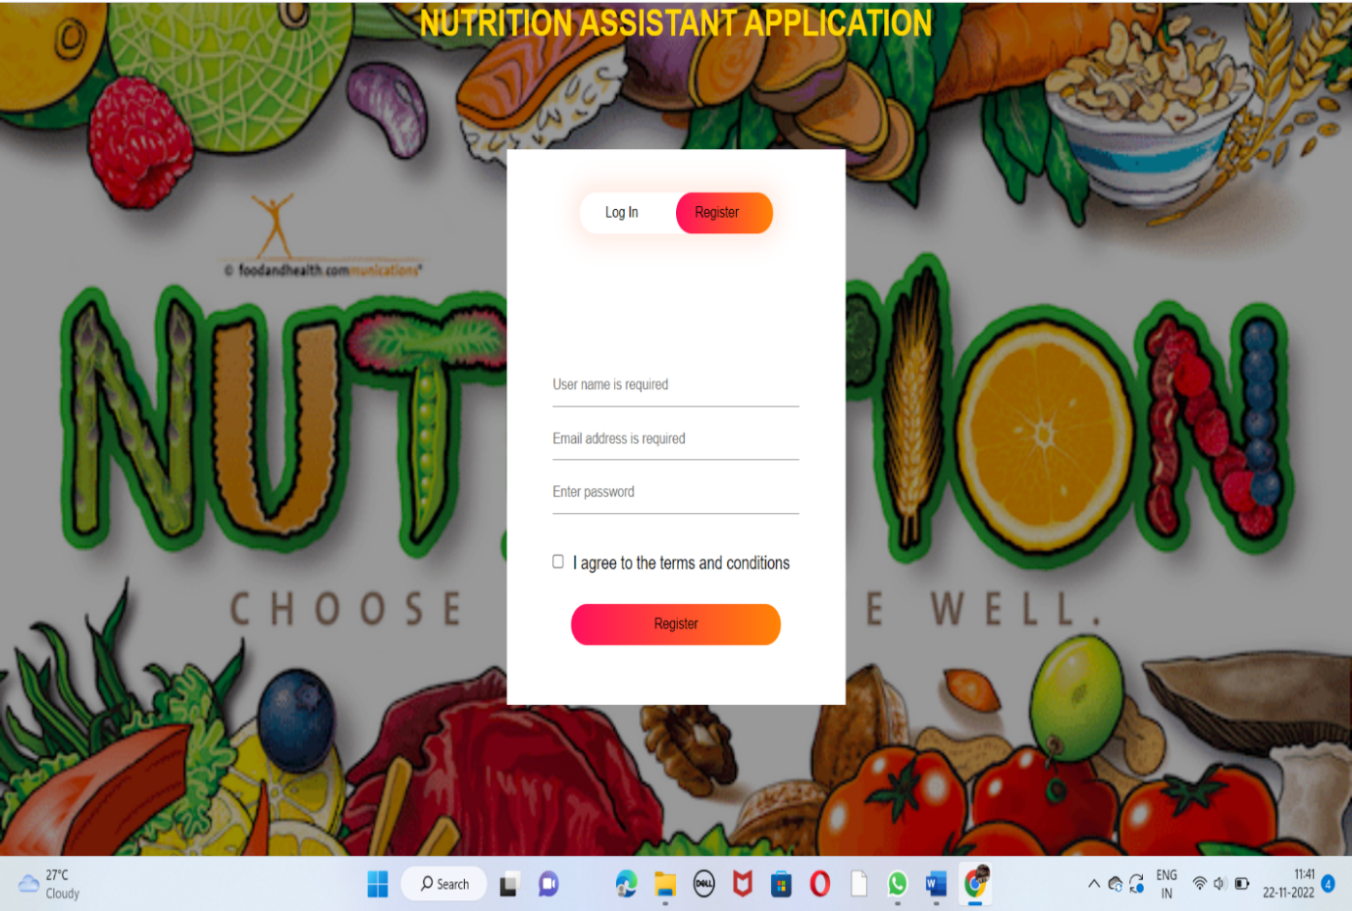

**ii)Login**

Existing user can use this app through entering their registered username and password.

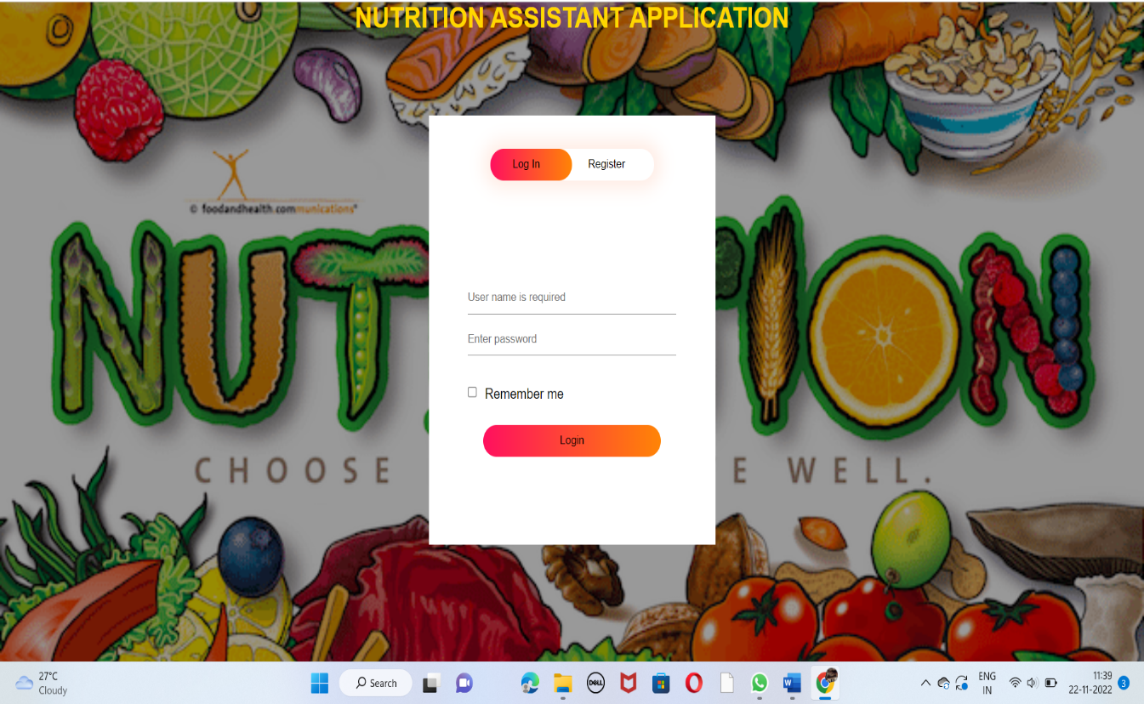

**iii)Dashboard**

After successful authentication the user will redirect to the dashboard.

